SWEDEN – DISCOVER THE “MIDNIGHT SUN” & “NORTHERN LIGHTS”

In Sweden , home of Volvo and the Vikings, you can travel quickly from the sophisticated to the wild. Ride a train north from Stockholm to Lapland, and you'll be transported from one of the most cultured, orderly cities in the world to the untamed beauty of Arctic wilderness. Whether you prefer strolling through museums or looking for moose in the forest, you'll find that Sweden is something special.

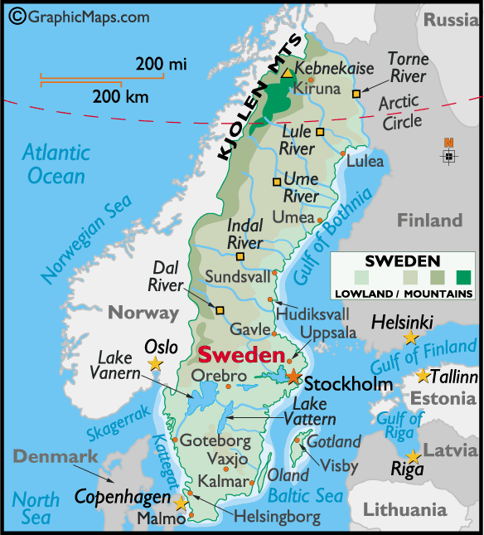

LOCATION :
Sweden shares the Scandinavian Peninsula with Norway, covering a total land area of 450,000 square km, making it the fifth largest country in Europe.

VISA The visa is to be obtained prior to arrival in the country

HOW TO GET THERE :
International Airport : Arlanda International Airport at Stockholm is the International gateway into Sweden.

Finair has good connections to Stockholm via Helsinki. Flying hours is approx. 10 hrs.
Also other European carriers fly to Stockholm via their home country.

GETTING AROUND :
AIR : Flying can be necessary given the large distances and winter conditions throughout the Nordic countries. There are good air links between Stockholm, Malmo, Gothenburg and other Scandinavian capitals.

TRAIN : Sweden's train system exemplifies efficiency and good design.
The X2000 is Sweden's high-speed train and can reach speeds of up to 125mph (200km/h). Certain Swedish trains have a dedicated Family Coach with a play area for children. Seat reservations are strongly advised and are compulsory in the case of X2000 and additional selected services.
It's a large country and Night Trains run over the longer routes. All trains have sleeping compartments, and some routes will include a Bistro coach and even a cinema.
There are metro systems in Stockholm, Gothenburg and Malmö. Stockholm's metro system, called the tunnelbana, is made up of nearly 100 stations, many of which have been decorated by local artists to bring a touch of character to the daily commute.
Rail passes
The Sweden Rail Pass gives you rail travel over the whole country. Note that for X2000 services a supplement is payable and reservations are still required. Tickets are available in first and second class and for varying periods. These passes are available through travel agents, only outside Sweden.
The ScanRail Pass is valid for unlimited rail travel with selected rail providers through Scandinavian countries and also provides discounted ferry travel on a range of routes, and free travel between Helsingør and Helsingborg
BUS : Buses are cheaper than trains, and equally comfortable, although longer journey times are involved.
All of Sweden's town and cities are connected by express bus services. Swebus Express (Tel: +46 (0)3-6290-8000) is the largest operator with over 300 interconnected destinations throughout the country. Under 25s, students and senior citizens receive a 30 per cent discount while children under six travel free.
Distances :
The following table provides approximate driving distances between selected cities. Kilometres in the lower left of the table, miles in the upper right.

City | Sto | Kar | Got | Mal | Vas | Kar | Ost | Osl
Stockholm | • | 196 | 292 | 384 | 67 | 309 | 339 | 336
Karlstad | 315 | • | 154 | 321 | 129 | 291 | 341 | 141
Gothenburg | 469 | 247 | • | 170 | 237 | 229 | 489 | 196
Malmo | 617 | 517 | 273 | • | 370 | 128 | 656 | 364
Vasteras | 108 | 208 | 381 | 597 | • | 302 | 322 | 270
Karlskrona | 497 | 468 | 268 | 206 | 486 | • | 647 | 423
Östersund | 546 | 549 | 787 | 1056 | 518 | 1042 | • | 360
Oslo | 541 | 227 | 316 | 585 | 434 | 680 | 579 | •
CURRENCY :
The currency is Swedish Krona (SEK). SEK1 = 100 öre

BUISNESS :
Banks open at 09h00 Mon-Fri and close at 15h00. On Thursdays highstreet banks usually stay open until 17h30. Main big city branches and those at transport hubs will usually be open later every weekday.
Shops in Sweden tend to keep quite uniform hours, mainly 09h00-18h00 each day. Many shops close for an extended lunch hour from 13h00 - sometimes not opening their stores again until as late as 16h00. However, in cities and large towns you'll usually find some shops open through the day as well as department stores that habitually keep later shopping hours

CLIMATE : The best time to visit Sweden is during the summer period of May-Aug. However, owing to its extreme length there is great variation in weather conditions throughout the country. In general the south is warmest, seldom colder than zero degrees Centigrade in even winter, while the north can be bitterly cold. Winter is wonderful for the Northern Lights.

TIME :
Sweden is 5 hours behind India.

ELECTRICITY :
Electricity supply is 230 volts throughout Sweden

DIALLING CODE :
International dialling code: | 46
Area codes: | Stockholm: 8, Gothenburg: 31, Malmo: 40, Östersund: 63, Karlstad: 54

TIPS :
Service charges are often included in restaurant bills and are factored into taxi bills. Consequently there is no need to make additional tips. If you choose to tip in the case of exceptional service then hand your donation directly to your server rather than adding it to the bill.

LANGUAGE :
Swedish is the official language spoken. English and Finnish are the languages also spoken.

INFORMATIVE WEBSITE :
www.visitsweden.com

CITIES :
STOCKHOLM :
Consistently rated Europe's most attractive capital city, Stockholm manages to be relaxed, charming and impeccably civilised. Capital cities are seldom representative of their countries, but Stockholm is a manifestly Swedish city, exhibiting the national love of open spaces and intelligence in urban planning that together make this a wonderful place to visit.

Accomodation Options in Stockholm :
Stockholm straddles an archipelago occupying in total 14 interlinked islands, although for tourist accommodation purposes though there are four main areas to consider:
The Gamla Stan (old town) is the tourist centre and accommodation here tends to be expensive but is very conveniently located for the city's most venerable attractions. The centre of town leading up to the Humlegården has a good choice of upmarket hotels close to shopping and cultural entertainment. Just north of this area, the Birger Jarl offers extremely comfortable accommodation, with well-appointed rooms beautifully decorated in contemporary Scandinavian style and good facilities including gym and sauna. The area west of Cityterminalen over to Kungsholmen has a wide range of hotels with a good selection of cheaper accommodation available. This area is perfectly situated for trains and buses to/from Stockholm.
Finally, the island of Södermalm has the widest range of accommodation, from luxury to budget. One of the best bets in this area is the Clarion, a large, modern, purpose-built hotel with minimalist décor and comfortable rooms. The Clarion also has a popular restaurant and bar though it's within easy reach of local nightlife and restaurants too.
One of the popular accommodations is the : Ice hotel in Jukkasjarvi (12 kms from Kiruna airport & 17 kms from Kiruna station)
The summer months of Jul-Oct are peak season when you are advised to reserve accommodation well in advance.
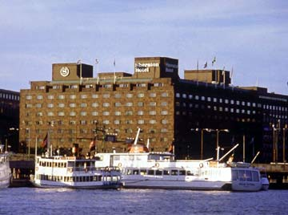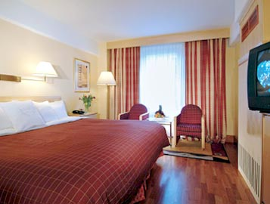

Must – Sees :
The Royal Palace :
The largest official royal residence in the world, the Royal Palace occupies a big chunk of Gamla Stan (the old city centre) and offers several interesting museums as well as a tour of the sumptuous royal apartments.
Kungliga Slottet. Gamla Stan. Open: Most museums in the palace open 10h00-16h00 (May-Sep); 12h00-15h00 (Oct-Apr). Admission: SEK80 for individual museums. Tel: +46 (0)8-402-6130.

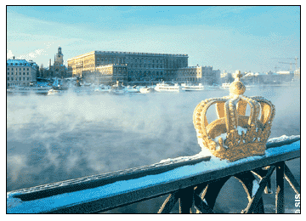

Drottningholm Palace :
The home of the royal family since the 1980s this 17th-century baroque Drottningholms Slott sits in landscaped Anglo-French style gardens, 10km west of the city.
It is worthwhile to make the effort to come out here, particularly in summer when steam boats connect the palace with the city centre. At the palace you can see some of the apartments that have been home to Swedish nobility for over 300 years. Listed as a UNESCO Heritage Site, the interior ranges from the original baroque features (such as the massive grand staircase or the sumptuous State Bedchamber) to the later additions of the library and long gallery.
While in Drottningholm you should also visit the Drottningholm Palace Court Theatre and the Chinese Pavilion, also on the UNESCO World Heritage list.
The best way to get here is via the steamer ferry from Stadhusbron (1hr). The ferries run across Lake Mälaren to the Palace regularly from May-Sep, with one boat leaving at least every hour. There are only two boats a day Sep-Oct and no winter service. Cost: SEK140 single, SEK150 return. Tel: +46 (0)8-587-140-00. The palace is also reachable on the underground (Brommaplan station).
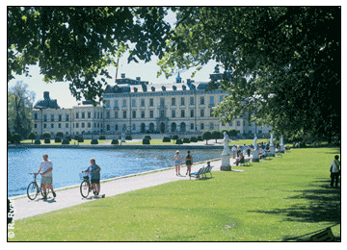
Gamla Stan : The Gamla Stan (old town) is rich in character and still bears a medieval romantic quality unaffected by the chattering tour groups and numerous souvenir shops. With the palace and its various peripherals taking up the bulk of the island the Gamla Stan contains several of the city's key attractions, but is a lovely area to explore in its own right.
At Köpmantorget Square stands a magnificently ornate statue of a grimfaced St George slaying a dragon. The statue is the centrepiece of the confluence of five narrow streets and is faced by tall medieval buildings with rusted paint façades. You can choose any of the streets to begin an exploration but walking right from here will take you into Österlånggatan, an avenue filled with antique shops, small commercial art galleries and fascinating naval memorabilia stores.
A more famous statue of St George is located in the nearby 13th-century Stockholm Cathedral (Storkyrkan). This 500-year-old statue is made from solid oak and features real elk antlers. The icon is reputed to hold genuine relics of the saint. Both of the statues symbolise Sweden's defeat of arch-enemy Denmark in 1657. The cathedral itself is an attractive building and well worth a visit.
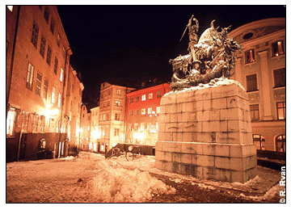

Skansen :
See the whole country - in a single day. Skansen is the world's oldest and largest open-air museum and you should plan on spending at least half a day here, if not more.
The park is a faithfully rendered miniature Sweden created by transplanting actual buildings representative of Sweden's history and cultural diversity. There are authentic Viking huts, a Sami village, a 15th-century windmill and a variety of typical homesteads. In summer, staff dress in period costume and perform various traditional tasks.
In the Tobacco and Match Museum you can learn about the wicked weed and ogle the world's largest cigar: 6m long and weighing 112kg. Deep in the bio-park area of Skansen you can find the particularly interesting zoo with immense bison, wolves, brown bears, moose, playful seals and otters.
Djurgårdsslätten. Open: daily 11h00-17h00. (May-Sep); 11h00-15h00 (Oct-Apr). Admission: free. Tel: +46 (0)8-442-8026.
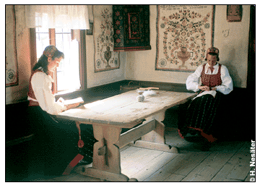

Nobel Museum :
Sweden's most respected cultural institution, with the possible exception of pickled herring, is the Nobel Prize, the premier worldwide acknowledgement of great achievements in peacemaking, science or the arts.
To mark the centenary of the illustrious prize the Nobel Foundation has created an exhibition entitled "Cultures of Creativity" to celebrate the 700-plus laureates who have received the award since its inception. If all that makes you hungry, make a reservation for the Stadshus Källeren, a five-star restaurant that offers the full menu from any Nobel banquet from 1901 onwards, presented on the classic Nobel table setting. Stockholm city hall. Tel: +46 (0)8-5063-2200.
Nobel Museet. Stortorget. Open: Tue-Sun 11h00-17h00 (until 20h00 Tue). Admission :SEK50. Tel: +46 (0)8-23-2506.
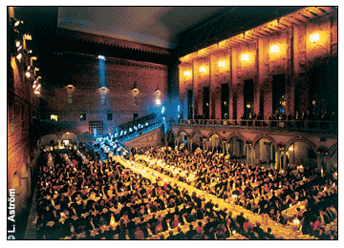

Excursions :
Visby (Gotland) : Gotland is the largest island off the Swedish mainland and is accessible by airplane or ferry from Stockholm or Västervick. The main attraction is the historic town of Visby, which has been continually inhabited for the last 5000 years.
The entire town - encircled by a 3.6km-long 13th -century wall - is on the Unesco World Heritage List as a site of outstanding cultural value. The Wall has over 40 towers and was originally built to separate the city's foreign traders from the local inhabitants. The rest of Gotland is ideal for walking or cycling along quiet country lanes and contains some of the nation's oldest and most interesting historical relics and ruins.
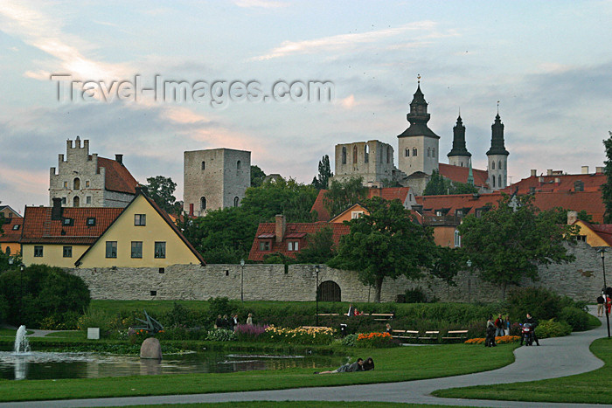

Uppsala :
Located 70km north of Stockholm, Uppsala is Sweden's fourth biggest city but it retains the charm of a small town. Old Uppsala, on the outskirts of the modern day centre, is a World Heritage site and is referred to as the Cradle of the Swedish State. It is easy to see why with a range of attractions that act as a timeline of Swedish history.
There are several good Viking sites and relics, and royal burial sites that precede even these (Uppsala was the seat of the pre-Christian Kings of Svea).
The city can boast the largest cathedral in the whole of Scandinavia - an impressive 13th-century structure that completely dominates the skyline. Uppsala University is the oldest university in the region, established 500 years ago.
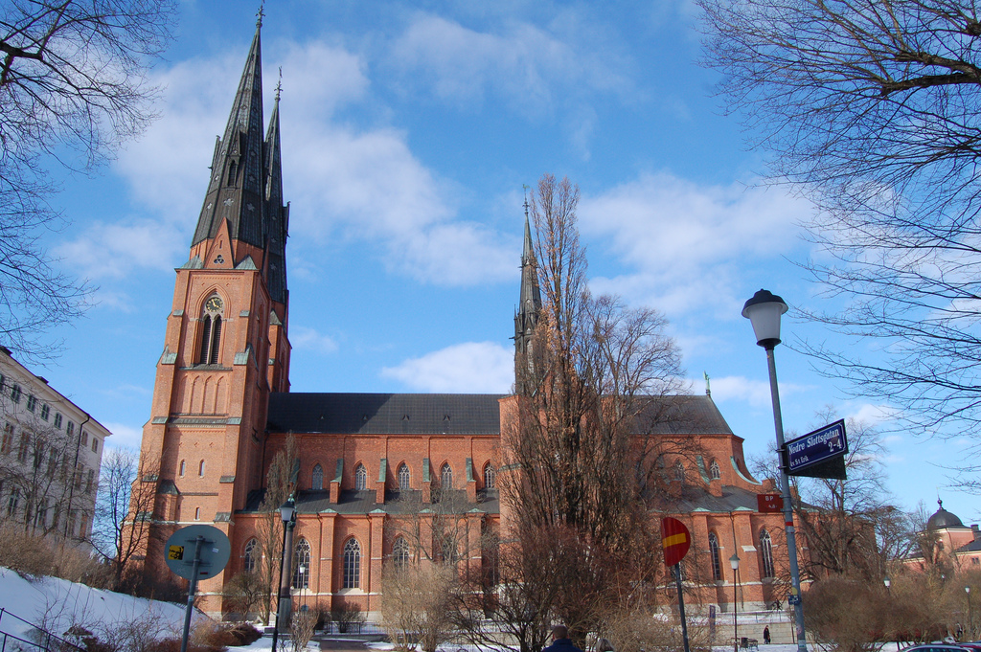

GOTHENBURG :
With an estimated 175 square metres of parkland for each of its half million inhabitants, clean air and swept streets, Sweden's second city is so spacious and airy that it hardly seems like you're in a city at all. With plenty of attractions you can do as much or as little as you like, and you can't help but return from a city break here feeling refreshed and rejuvenated.
Accomodation Options in Gothenburg :
Gothenburg has a good choice of accommodation, ranging from plush hotels to more basic bed and breakfasts. One of the best areas to look is around the central railway station, where there is a glut of medium-priced hotels. One of the best options is the Opera, which is quite cosy and old fashioned as well as being very convenient for shops and attractions. Further afield is the Spar Garda, a bit of a walk from the centre but a very economical option for those on a tight budget.
A more deluxe option is Gothia Towers. Housed in two enormous tower blocks, dominating the city skyline, Gothia Towers is just a short hop from the Liseberg and well placed for visiting the Museum of Art. The entire hotel is decorated to a very high standard and has good facilities including a pleasant bar and restaurant offering great views over the city.
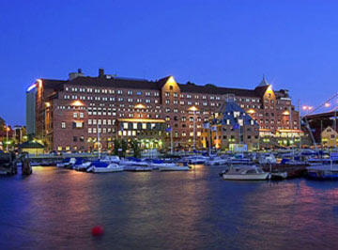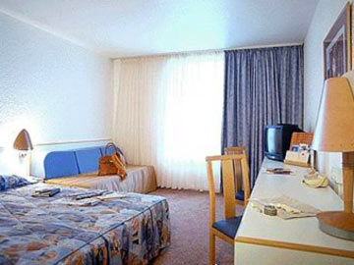

MUST – SEES :
Liseberg : Gothenburg boasts Scandinavia's largest amusement park and Sweden's biggest tourist attraction at Liseberg, which is within striking distance of the city centre. The park's main draw is Balder, the largest wooden roller coaster in Scandinavia. Not for the fainthearted, this terrifying journey lasts three minutes as you travel at 90km per hour along over 1,000 metres of wooden track down steep drops and tight corners. There are lots of rides for the younger guests too, including carousels, mini roller coasters, kiddies' bumper cars and boat rides. If rides aren't your thing the park's numerous stages provide live music, comedy, dance and entertainment while the 3D cinema Maxxima offers cutting edge visual entertainment. Alternatively simply while away the hours wandering the stunning grounds.
Park open: Apr-Sep & mid-Oct-Dec. Admission: SEK60. 1 ride coupon: SEK15. 1-day ride-pass: SEK270. 2-day ride-pass: SEK350. Tel: +46 (0)31-400-100.
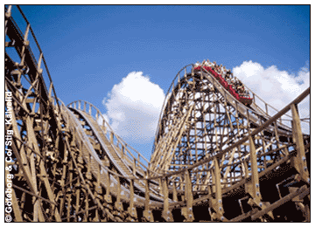

Maritime Centre :
Gothenburg's maritime centre is one of the largest floating ship museums in the world, with a fleet of 18 ships and boats, which you are free to roam. The collection includes the submarine Nordkaparen built in 1962, and it is well worth confronting your claustrophobia to climb down the hatch and experience the cramped conditions where 37 seamen amazingly lived and worked. The museum includes a restaurant aboard the harbour's old transport ferry Dan Broström, which also serves as the entrance to the museum.
Located on Packhuskajen. Open: 10h00-16h00 (until 18h00 May-Aug). Admission: SEK75, adults; SEK30, children. Tel: +46 (0)31-105-950.
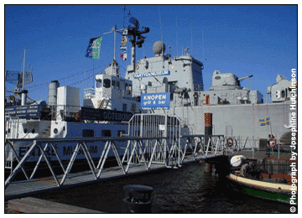

SHOPPING :
Apart from locally-produced globally recognised products Ericsson mobile phones, Ikea furniture, and Volvo and Scania motor vehicles, Sweden has plenty to offer the visiting shopper. With high taxes and a strong currency Sweden is no bargain centre, although quality is generally high.
Swedish glass is known throughout the world for its beauty and grace. Designers and craftsmen have always worked in close collaboration to produce glass and crystal ware of exceptional quality. The Småland area in the Southeast of Sweden is known as the Kingdom of Crystal due to the quality of the local sand and the skill of the craftsmen. Big names include Orrefors and Kosta Boda.
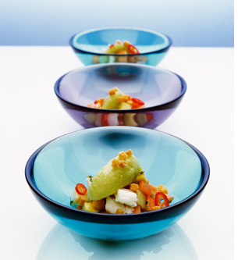
Linen is another good buy and many Swedish textile producers have achieved international stature. Wool jumpers and other winter clothes are of excellent quality, although strictly speaking many of the distinctive designs are likely to come from Norway, Finland or Iceland. Wooden Dala horses, manufactured in Nusnäs, are a typical souvenir most suitable for children, or adults with a good sense of balance and an infantile mentality.
You couldn't get more Swedish than functional Ikea furniture - but since its stores are mushrooming all over the world you can pick some up near your home - the selection doesn't vary much from what you see overseas.
FOOD :
While Swedish food lacks the culinary sophistication of French or Italian cuisine, it is celebrated for the excellence of its natural ingredients, particularly fresh and smoked seafood and game meats such as reindeer and elk.
INDIAN RESTAURANTS :
Govindas Vegetarian
Fridhemsgatan 22, Stockholm 10229
Tel : 08 654 9002

Little India
Kungsgatan 44, Kungshallen , 111 35, Stockholm 111 35
Tel : 08 20 4130

